**Train Model UI**

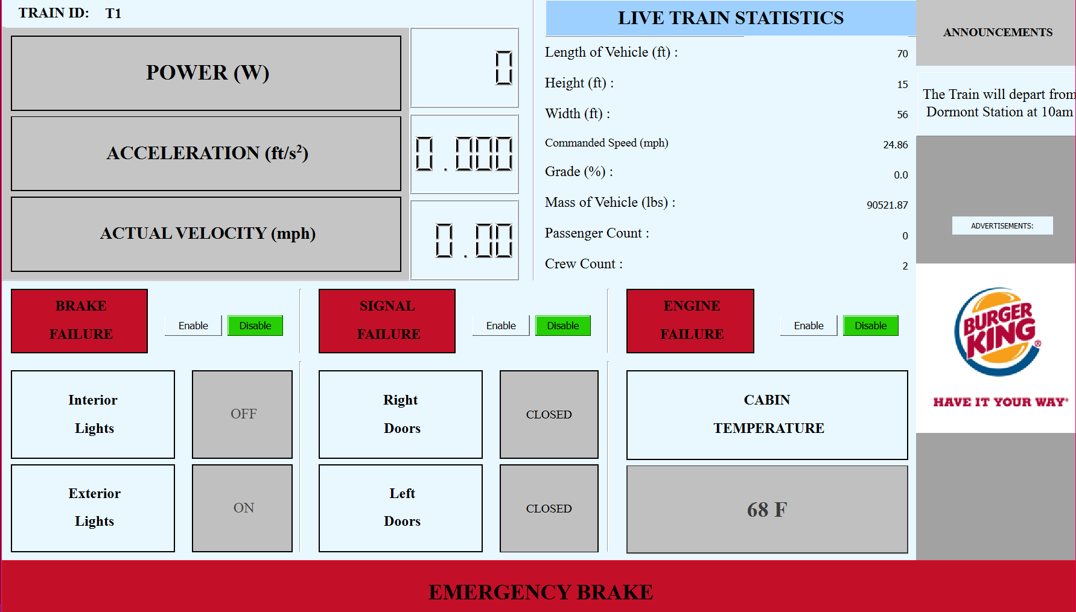

How to use:

1. The train model UI is user friendly and simple to use.
2. The left side indicates all the numbers calculated by using Newton's Laws.
3. The right side displays live train statistics.
4. Murphy’s failures can be sent using the Enable/Disable buttons by simply clicking on them.
5. The emergency brake can be toggled on the bottom.
6. As a user, you can view the status of the interior lights, exterior lights, doors and cabin temperature.